1. **Output of the first csv file.**



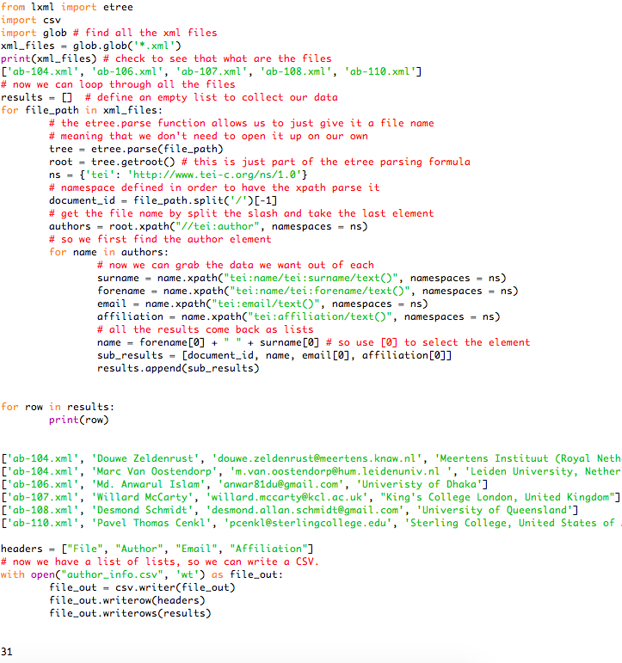

1. **Output of the second csv file.**



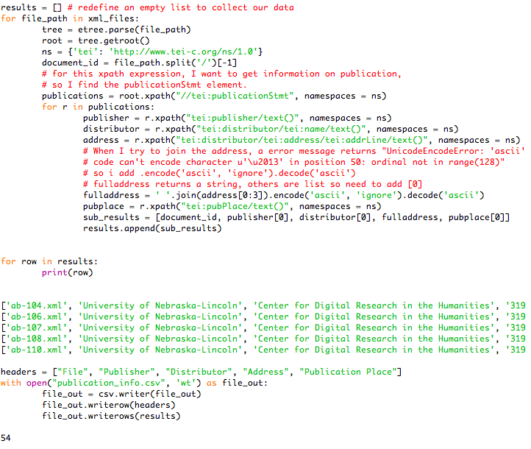

1. **Output of the third csv file**



